Nuclear Energy
Did you know that nuclear power is possibly the greatest source of energy in the universe? Most of the time when you think of nuclear power, you probably think of bombs and dangerous radiation. But nuclear energy is at the heart of all matter.
Where does nuclear energy come from? What is the difference between fission and fusion? How is nuclear energy able to make bombs and be used as a power source for electricity? How dangerous are nuclear power plants? What could happen if one near your home had a meltdown? You will all explore of these questions in this lesson.

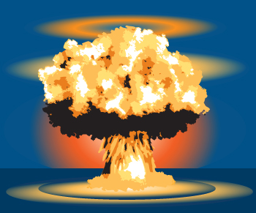

Organize What You Learn
Use this graphic organizer to collect ideas about nuclear energy. Define fission and fusion and provide an example of each type of reaction. Then answer the questions related to nuclear energy and nuclear power plants.

Origin of Nuclear Energy
An atom is made up of protons, neutrons, and electrons. The protons and neutrons form the nucleus of the atom, and the electrons exist in a cloud outside the nucleus. The negative electrons remain attracted to the atom because of the positively charged protons in the nucleus. But how do two or more protons remain tightly packed together in the nucleus? They are all positive and should be repelled by each other.
The force holding them together is called the strong nuclear force . This force only acts between protons and neutrons in the nucleus of an atom. It is so strong that it overpowers the repulsion between protons and holds them together. This force inside the nucleus is extremely powerful. When scientists realized that they could use this energy, the nuclear age began.
- What type of force attracts electrons towards the nucleus? The force that attracts the negatively charged electrons (in the electron cloud) to the positively charged protons (in the nucleus) is called an electrostatic force.
- How does this force compare to the strong nuclear force? The strong nuclear force is one hundred times stronger than the electrostatic force, which is why nuclear energy has such an impact.

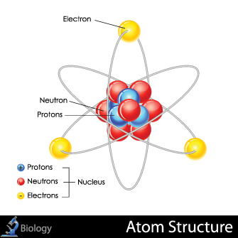

Nuclear Fusion
The greatest source of energy in the universe is called nuclear fusion . The stars, including the Sun, are enormous nuclear fusion power plants. These stars consistently convert hydrogen into helium. This conversion involves the combination of two isotopes of hydrogen (deuterium, also known as hydrogen-2) to create a helium-4 atom. Helium has two protons and two neutrons in its nucleus.
Interestingly enough, the mass of the helium-4 nucleus is less than the sum of the two protons and two neutrons that went into making it. That mass has been converted into energy. Perhaps you have seen Einstein's famous equation, E = mc². This is where it applies since mass can become energy.
Scientists have been working very hard to make fusion a reality here on Earth, but they have not yet succeeded. Take a look at some of the problems they have encountered.

Galleria

Materials to withstand intense heat

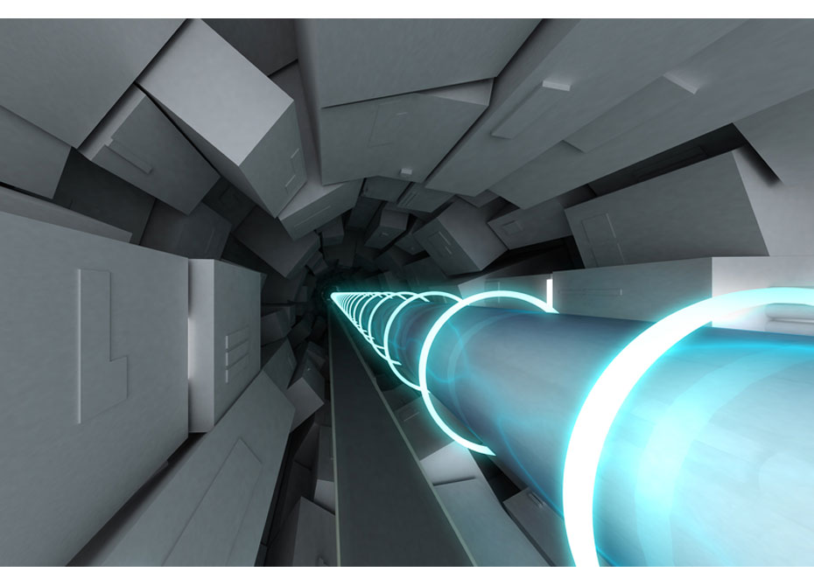
Particle accelerator

One of the products of a fusion reaction is fast-flying neutrons. These will pummel through the reactor chamber wall into a blanket of material surrounding the reactor, depositing energy as heat that can then be used to produce power. Currently, new technology is needed to create a material that will withstand the continual radioactivity and immense heat that is produced from a fusion reaction.

Confining radioactivity

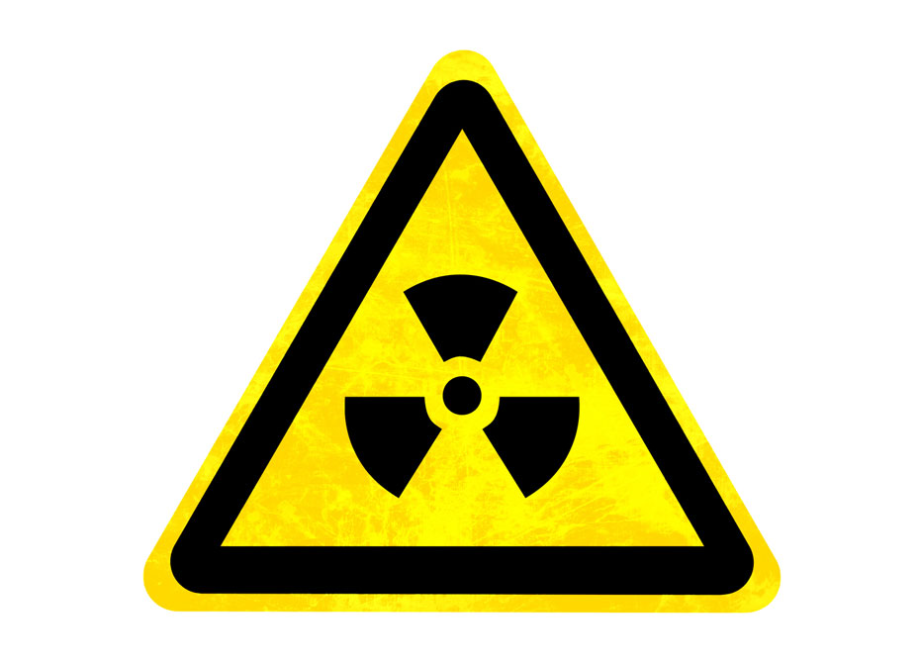
Yellow Radioactive Nuclear Sign

The radioactivity induced by neutrons, as well as the prevention of the release of radioactive tritium fuel, is a major concern. The plasma created from a fusion reaction and its interaction with reactor materials will also produce a radioactive dust that will need to be removed. It is hoped that future technology will take care of this concern.

Full-scale engineering
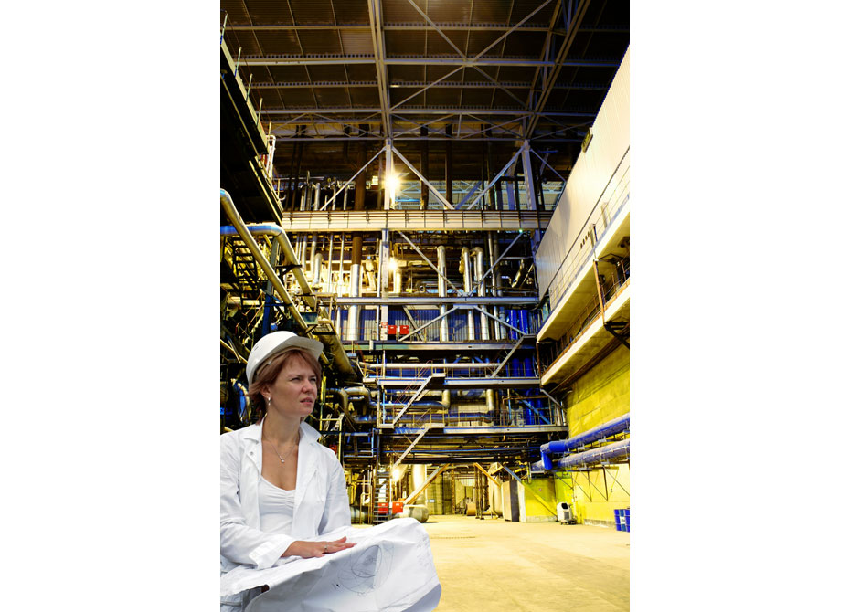
Woman nuclear engineer

Human-engineered fusion has already been demonstrated on a small scale. The challenges facing the engineering community are to find ways to scale up the fusion process in an efficient, economical, and environmentally safe way. Building full-scale fusion-generating facilities will require engineering advances to meet all of these challenges, including better superconducting magnets and advanced vacuum systems.
Nuclear Fission
Atoms with different numbers of protons are different elements. The smallest atoms are hydrogen (with one proton) and helium (with two protons). As you can imagine, as more and more protons are added, the nucleus becomes more packed. Uranium has 92 protons, and it is enormous! In fact, it is so big that it is unstable . To become more stable, it needs to become smaller by splitting into two smaller elements. This process of splitting a larger, heavier atom into smaller, lighter atoms is called fission . Fission, like fusion, converts some of the mass of the particles into energy, a lot of energy!
Scientists started experimenting with unstable elements and radioactivity about a hundred years ago. The beginning of the 20th century was an amazing time for discoveries about the power contained in an atom. Once scientists understood that the energy within atoms could be released, the race was on to be the first nation to harness this ultimate power of nature and make the most powerful weapons in the world.
- Do fission and fusion reactions produce the same amount of energy? No, fission reactions, while very powerful, create much less energy than fusion reactions.

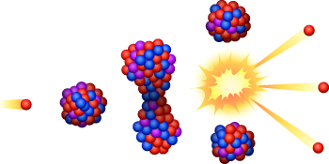

Nuclear Bombs
During World War II, American scientists, along with many European scientists who escaped from Nazi Germany, worked feverishly to beat the Nazis in creating a nuclear bomb. The science involved in making a nuclear bomb is called a chain reaction . A chain reaction is initiated when a neutron is bombarded at a high velocity into an already unstable atom of uranium. The added neutron forces the uranium to undergo fission, releasing two smaller, lighter isotopes and three neutrons. Each of the three released neutrons then hit a new uranium atom to split it, and suddenly there are nine neutrons being released! You can see how this reaction can grow exponentially. This kind of reaction leads to an explosive amount of energy all being released uncontrollably in a very short amount of time. This is how the bomb explodes.
America won the race in developing the first atomic bombs. They were used on Japan and ended World War II. Even today there is much debate about whether this was a good or bad decision.

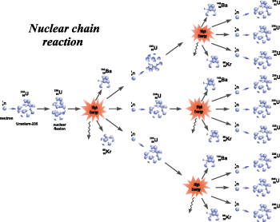

Nuclear Power Plants
A chain reaction can cause uranium to release exceptional amounts of energy. Scientists have figured out how to control the rate of the reaction so that it produces enough energy to heat water and turn it into steam but keep the uranium from going critical.
This is done by inserting control rods into the reactor. Control rods absorb the extra neutrons when a uranium atom splits. In this way, the rate of reaction is controlled by how many neutrons are allowed to hit additional uranium atoms. If the control rods are inserted far enough, they absorb so many neutrons that the reaction stops. But if they are taken out, the chain reaction could accelerate too quickly, causing a meltdown. If things were to go awry at a nuclear power plant, the long-term environmental effects could be extremely serious.
The dangers of using nuclear energy to produce electricity are very real but so are the benefits. A nuclear power plant is very clean in comparison to a coal burning power plant. In addition, the amount of raw radioactive material needed to produce the equivalent amount of energy is very small.
- How do control rods work? Control rods enable a controllable reaction to occur by absorbing released neutrons caused by the splitting of uranium atoms. This reduces the accelerated fission of the uranium.

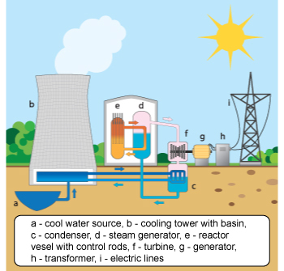

Controversy Surrounding Nuclear Power
There are many concerns about using nuclear power to produce electricity, but the greatest concern is nuclear waste . When uranium in a nuclear power plant stops reacting, it can no longer be used and must be disposed of. The problem is that waste products from nuclear reactions are still radioactive and will be toxic for a very long time. This means that they have to be packaged, stored, and monitored with great care. Any nuclear waste not appropriately dealt with could contaminate water supplies and cause other environmental hazards.
Nuclear power plants are extremely concerned with safety for obvious reasons. But even so, accidents can happen as was demonstrated in Japan in 2010. The Fukoshima nuclear power plant was damaged and overheated due to the earthquake and tsunami. Long-term effects of a nuclear accident or exposure to nuclear waste could include radiation sickness and cancer.
Many controversial issues surrounding nuclear energy have hinder its growth as an industry. In fact, the number of active nuclear power plants continues to decline.

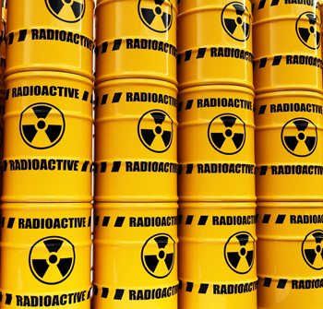

Assignment: Career Research Exploration

Complete a five-paragraph essay on a career in the field of energy. (PLEASE USE THE MY CAREER RESEARCH SHEET AS AN OUTLINE FOR THIS ESSAY).

